
COMSATS UNIVERSITY ISLAMABAD ATTOCK CAMPUS

Name: Zoya Fiaz
Registration No: FA24-BSE-022
Department: Software Engineering
Subject: Information Security
Submitted To: Mrs.Ambreen Gul
Submission Date: May 08, 2026
Submission Day: Thursday

ASSIGNMENT 4

Question no.01:
Task 1 — Simple RSA Implementation (Without Libraries)
Goal: Understand how RSA actually works inside — small primes, manual calculations, own encrypt/decrypt functions.

RSA works in 3 steps:
1. Key Generation
We start with two small primes:
- p
- q
Then we find:
- n = p × q → this becomes part of the public key
- phi = (p−1)(q−1) → used to find e and d
We choose a number e such that:
- 1 < e < phi
- gcd(e, phi) = 1 (meaning e and phi share no common factors)
Finally, we compute:
- d = modular inverse of e mod phi
So:
- Public key = (e, n)
- Private key = (d, n)

2. Encryption
Formula:
cipher = (message^e) mod n
3. Decryption
Formula:
plain = (cipher^d) mod n
This works because of number theory (modular exponent rules).
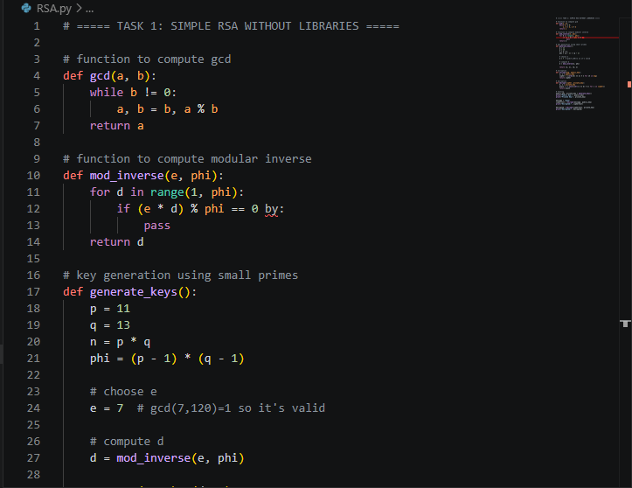
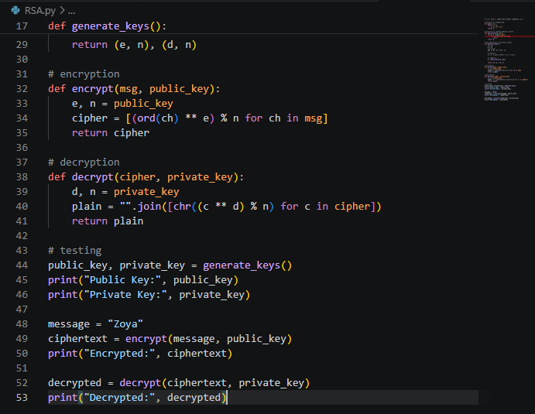
Output:

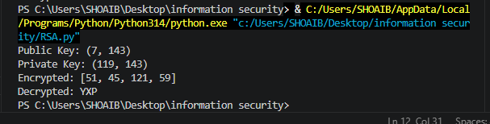

Question no.02:
Task 2 — Digital Signature Using RSA + SHA256

Digital signatures work like this:
- I write a message.
- I generate its hash using SHA-256.
- I encrypt that hash with my private key → this becomes the digital signature.
- Anyone can verify by:
  - Hashing the message again
  - Decrypting the signature using my public key
  - If both hashes match → message is original and not changed
If even one letter changes, the hash changes completely and verification fails.

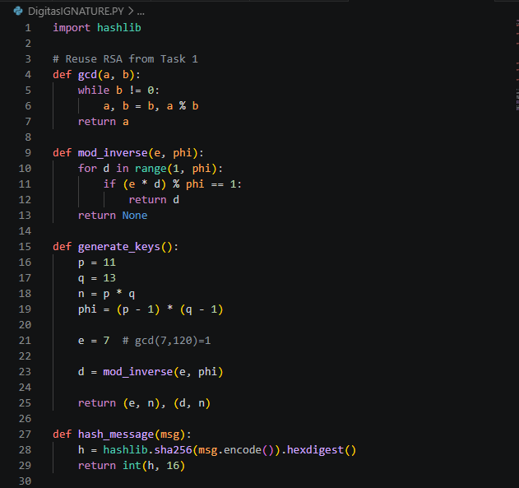
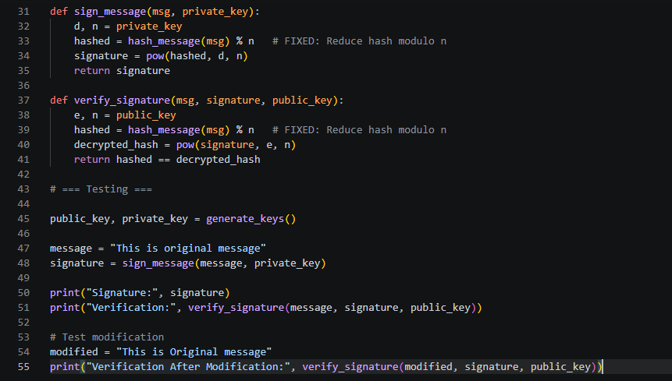
Output:
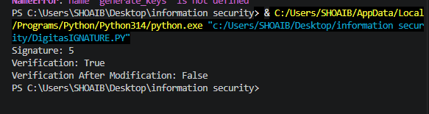
Security Analysis:
- RSA is secure because breaking it requires factoring a very large number (n = p × q).
- In our assignment, we used small primes only for learning. Real RSA uses primes of 2048+ bits.
- Digital signatures provide:
  - Authentication → signature proves who sent the message
  - Integrity → if message changes, signature fails
  - Non-repudiation → sender cannot deny signing
Hashes are important because they turn long messages into a fixed-size output that is secure and impossible to reverse.

